Linux Fundamentals
================================================================
Submitted to Vikul_Sir
Submitted by Nalathati Rahul
Submission Date –03/Feb/2026
================================================================
L4 - In EC2 Ubuntu Instance install JDK and setup JAVA_HOME path environment variable

Step:1 login into AWS console with credentials
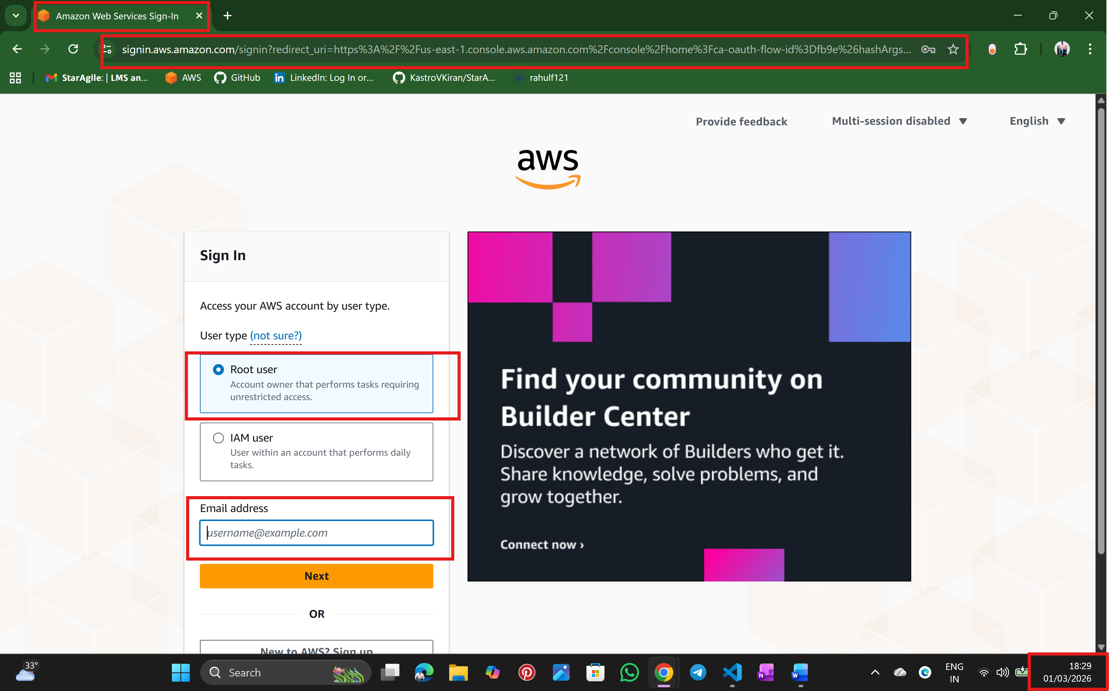
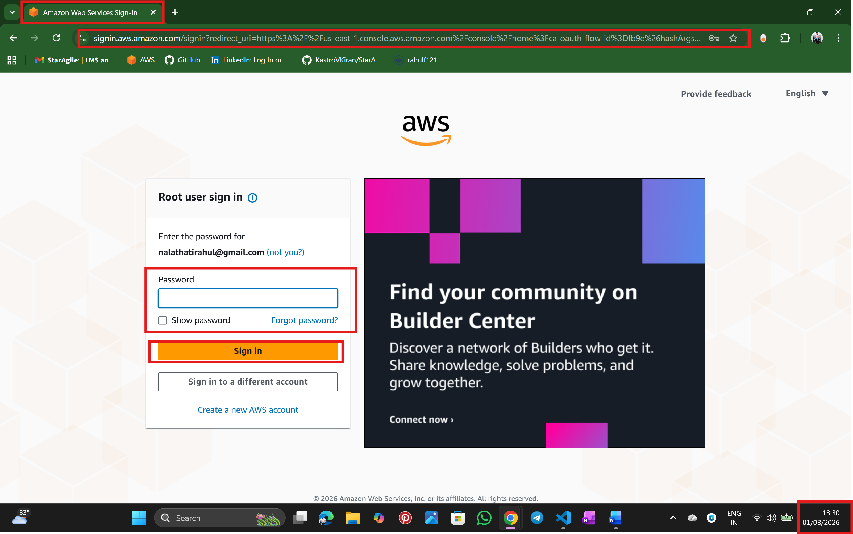
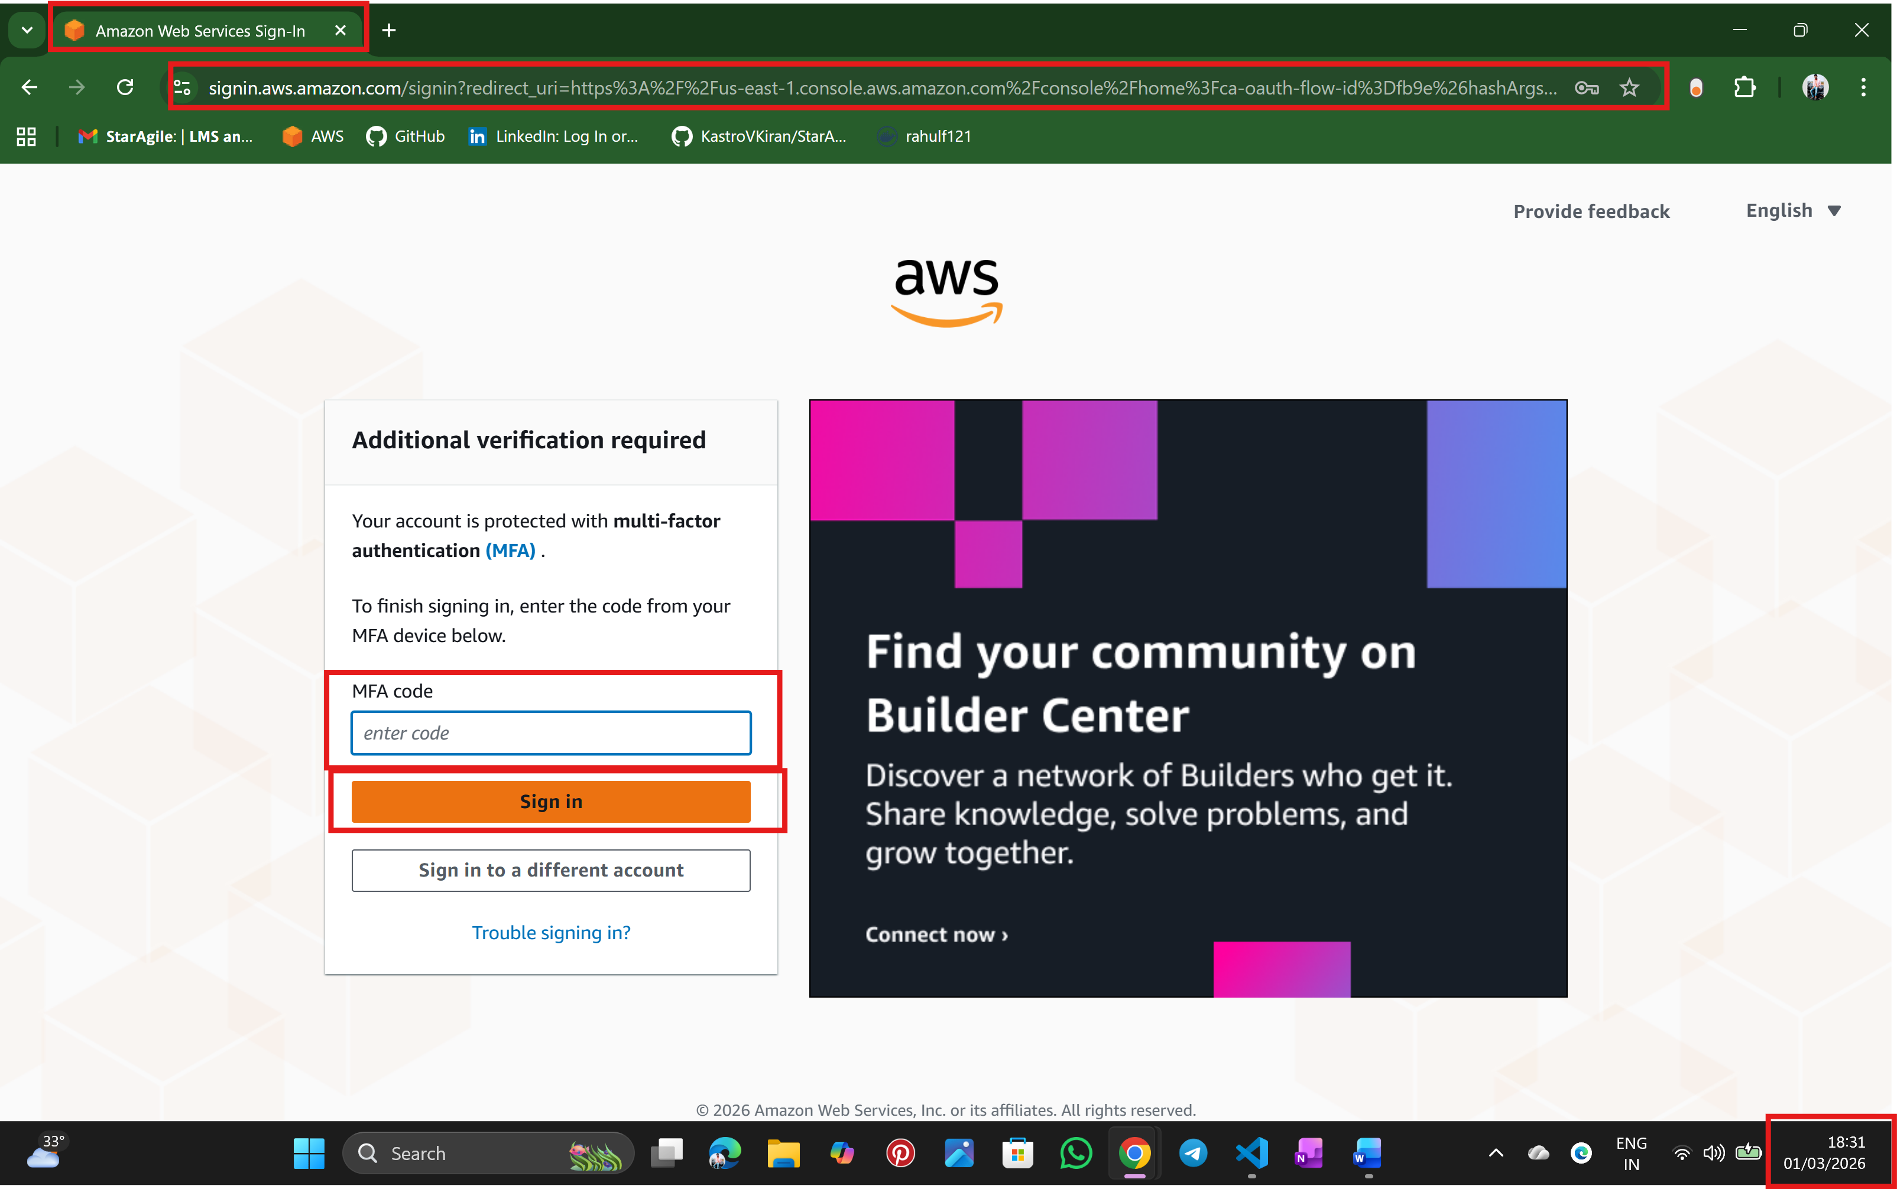

Step:2 Go to EC2 service
Select instance name
Select AMI type: Ubuntu
Select instance type
Create keypair
Allow SSH Security group
And finally create a launch instance
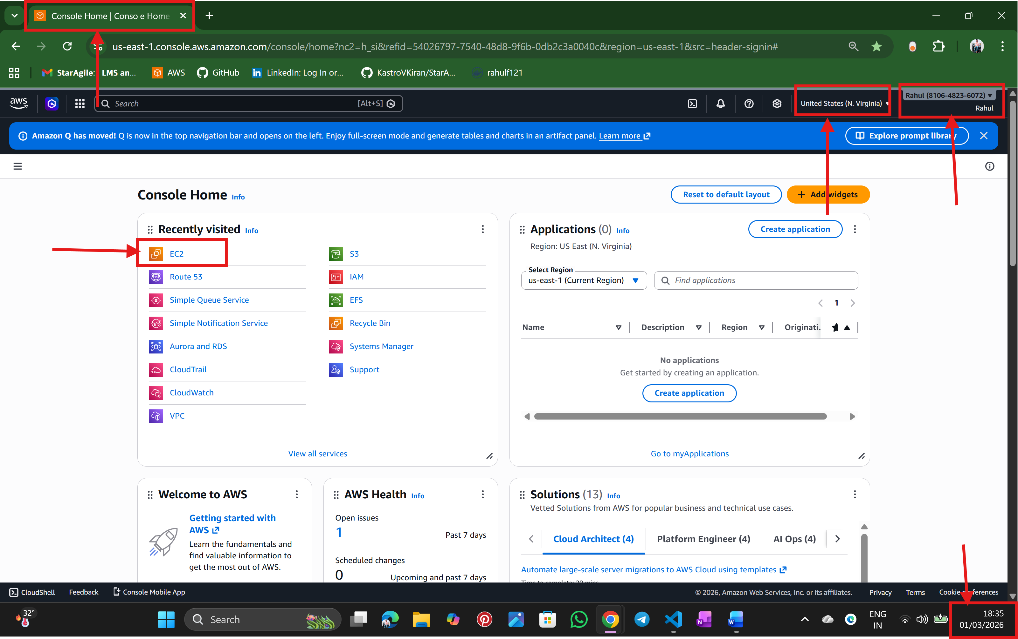
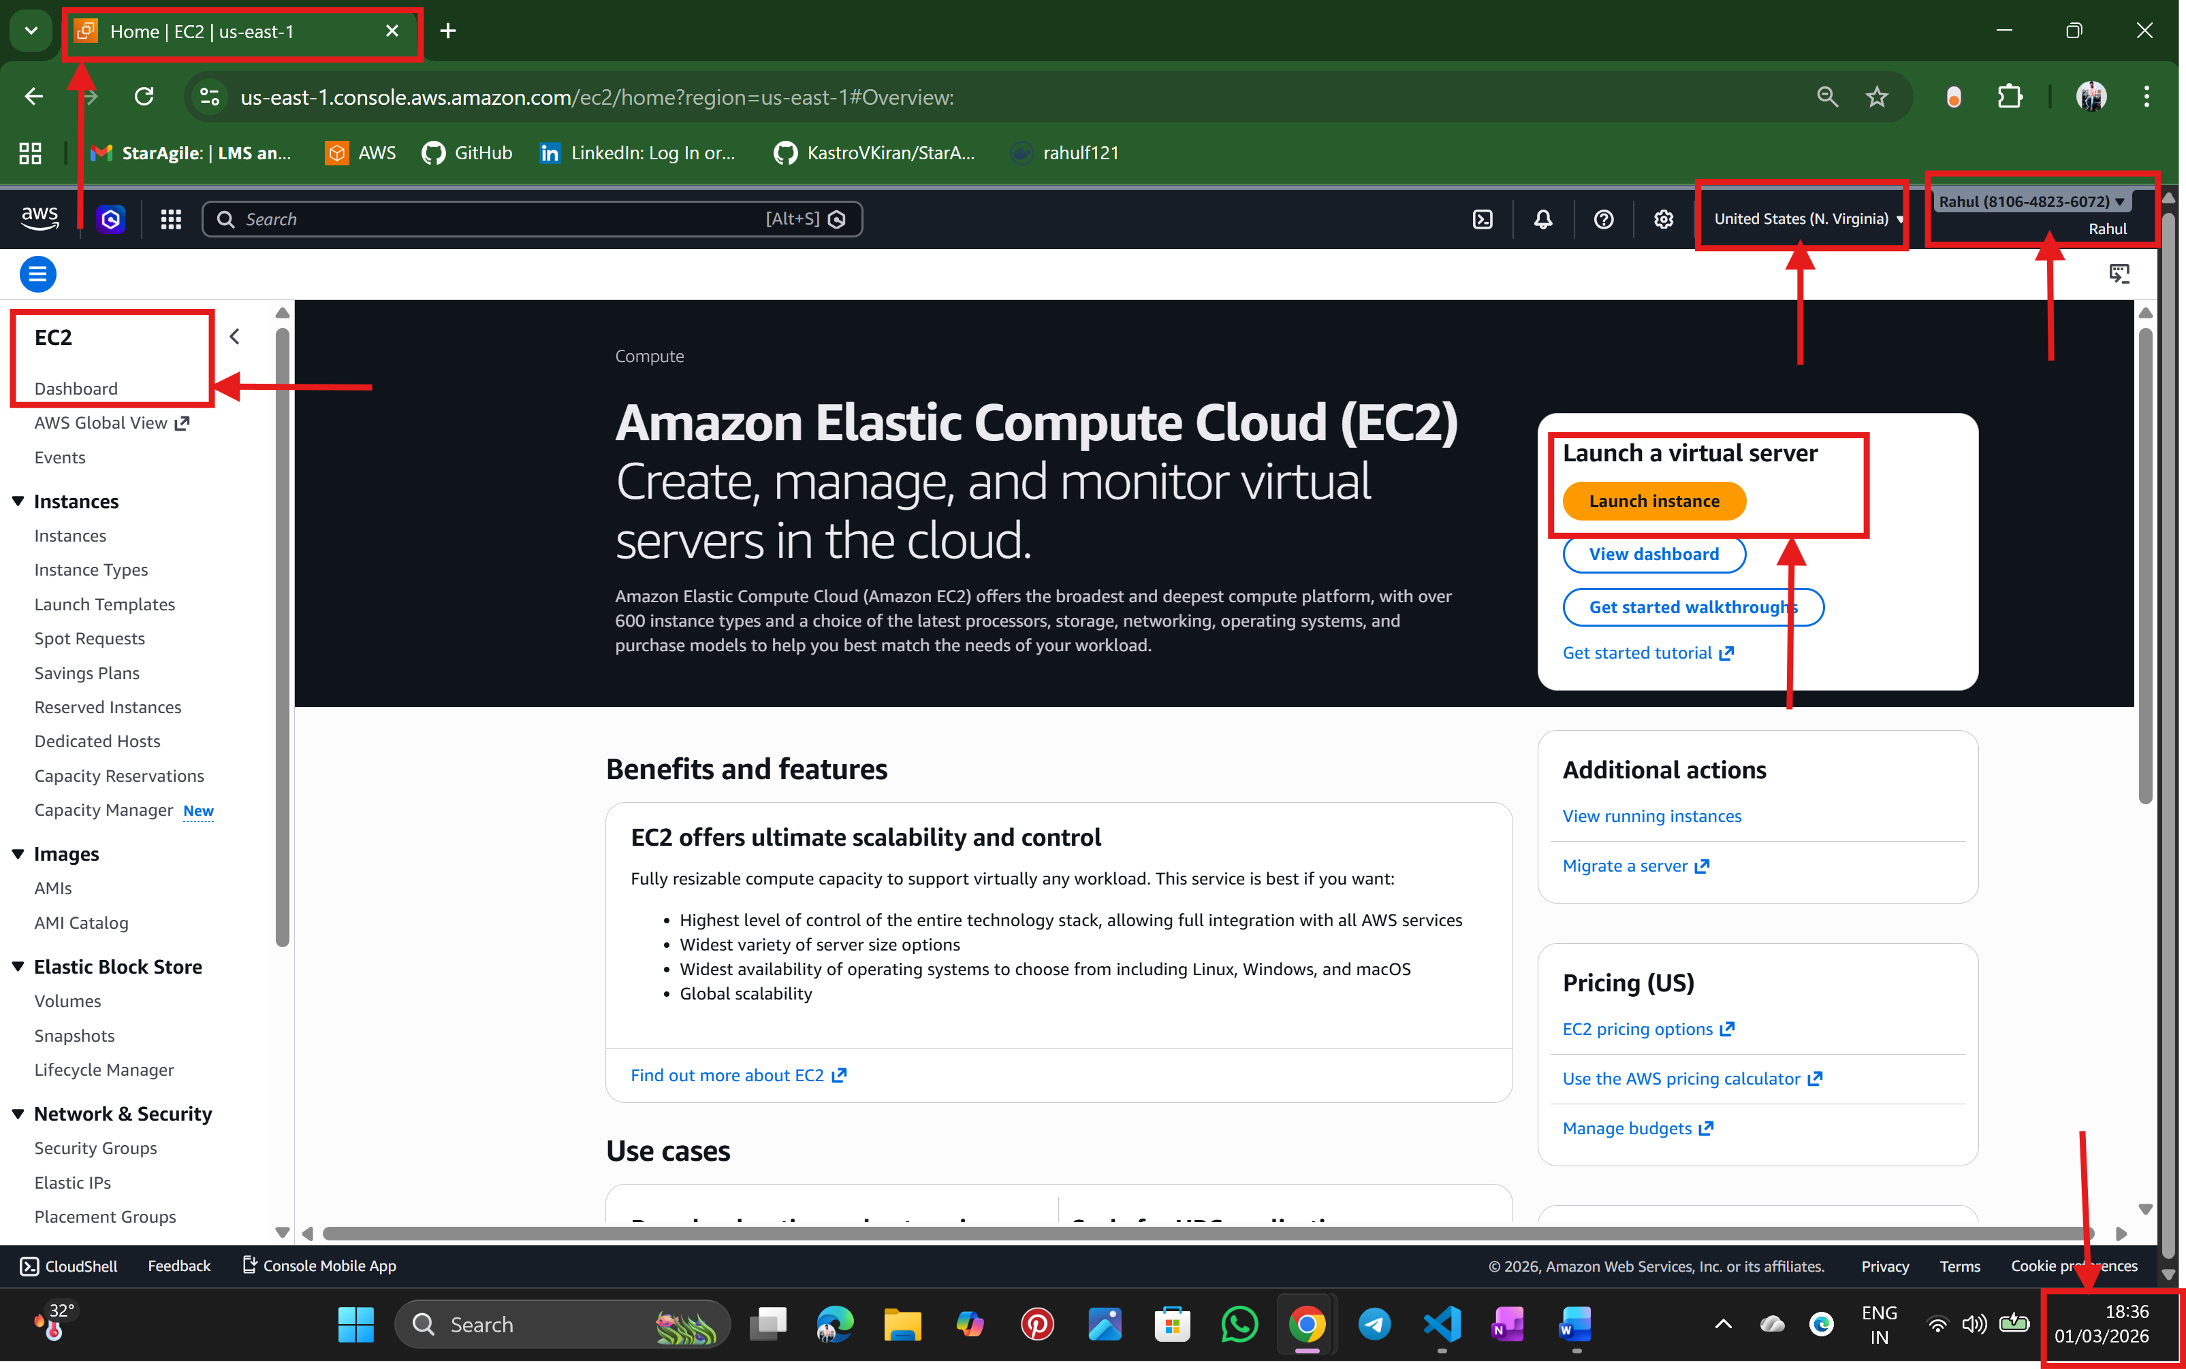
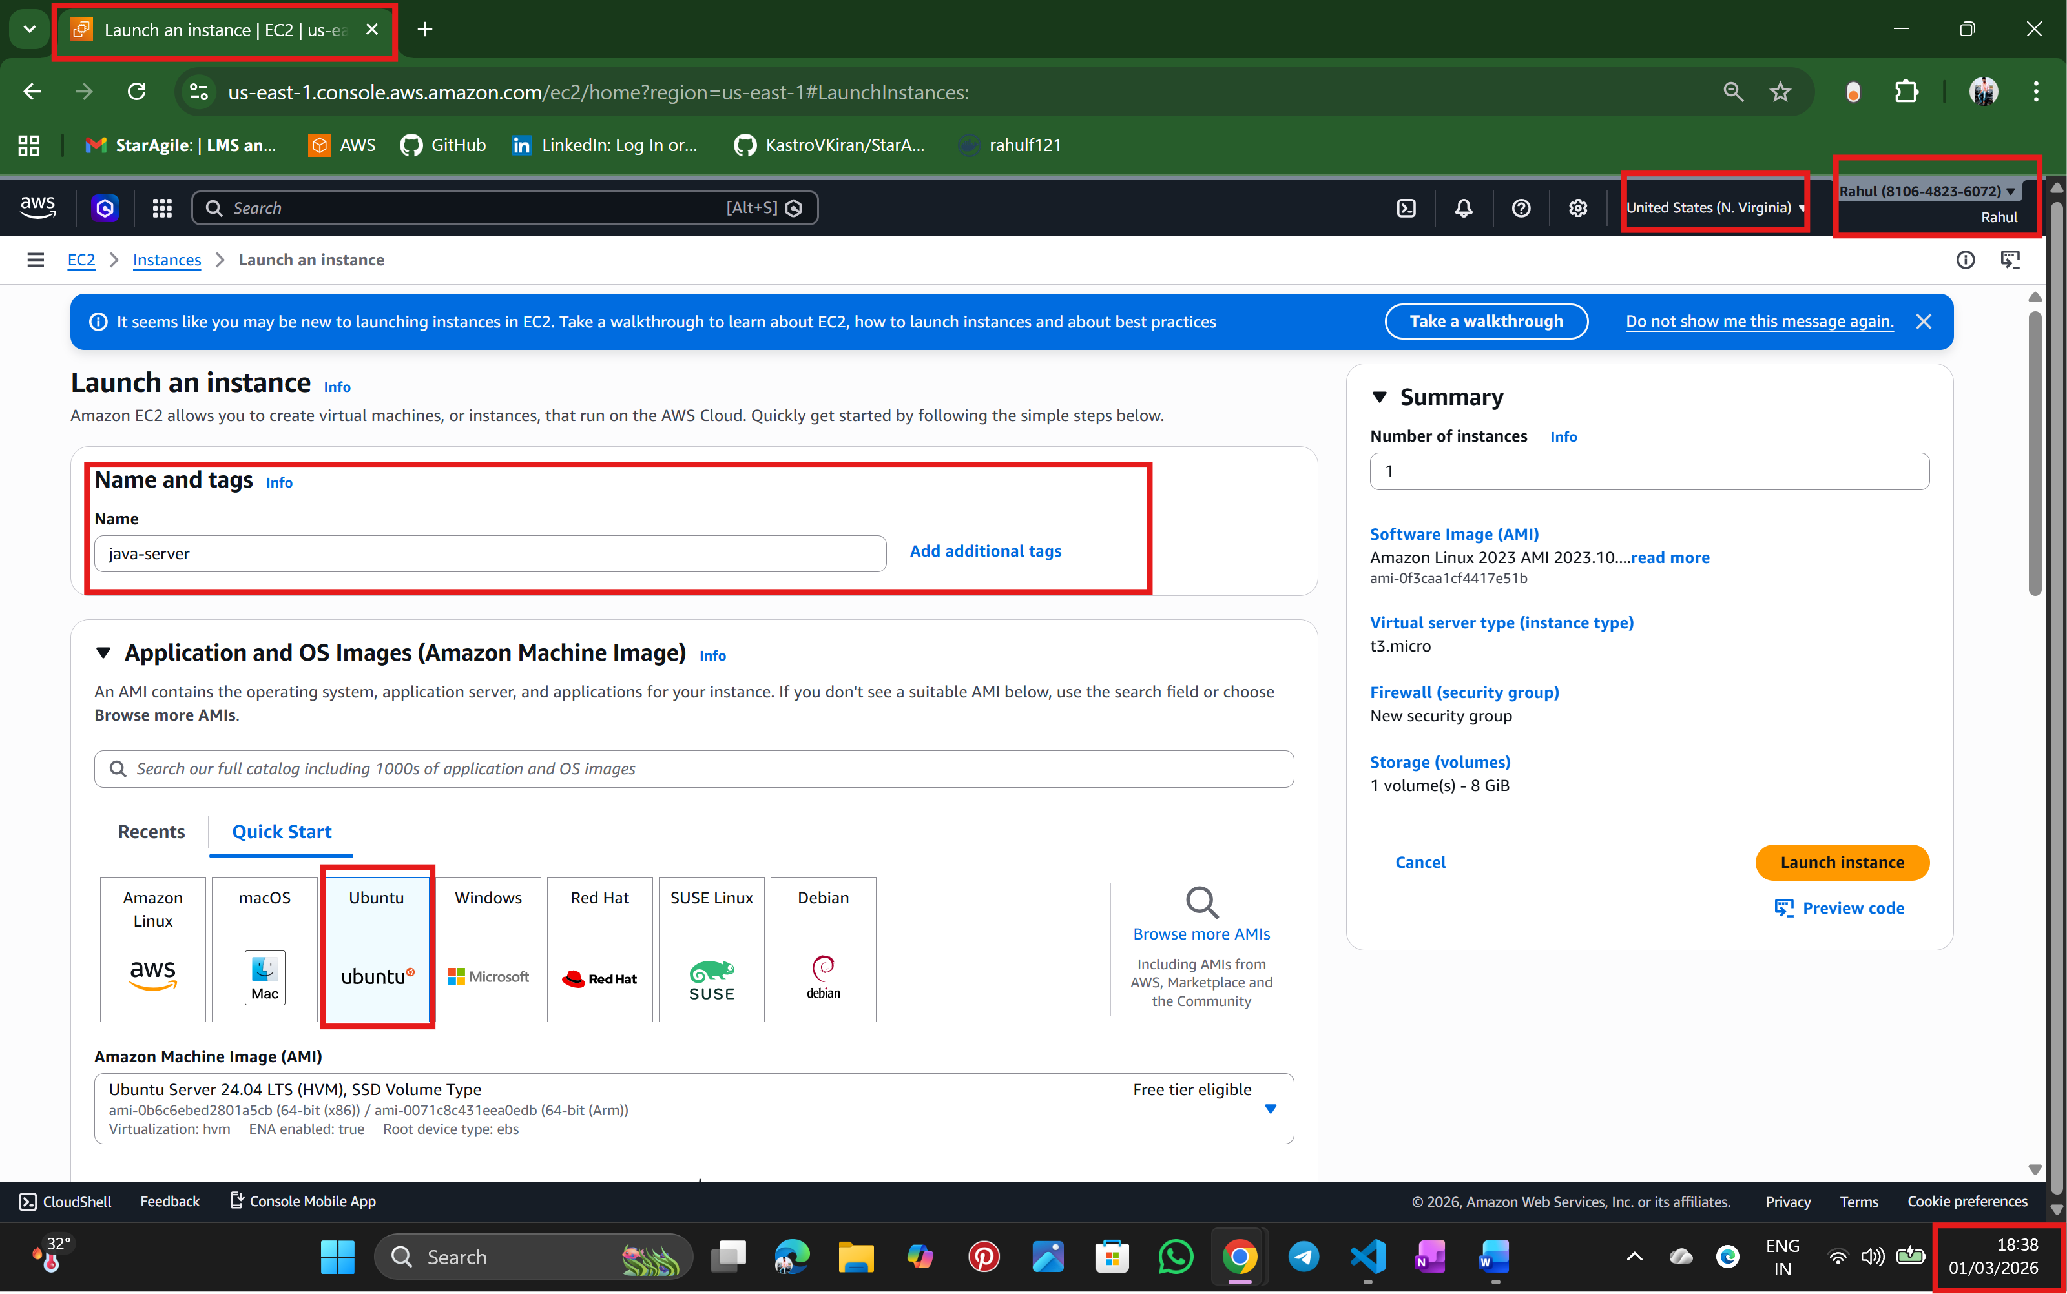
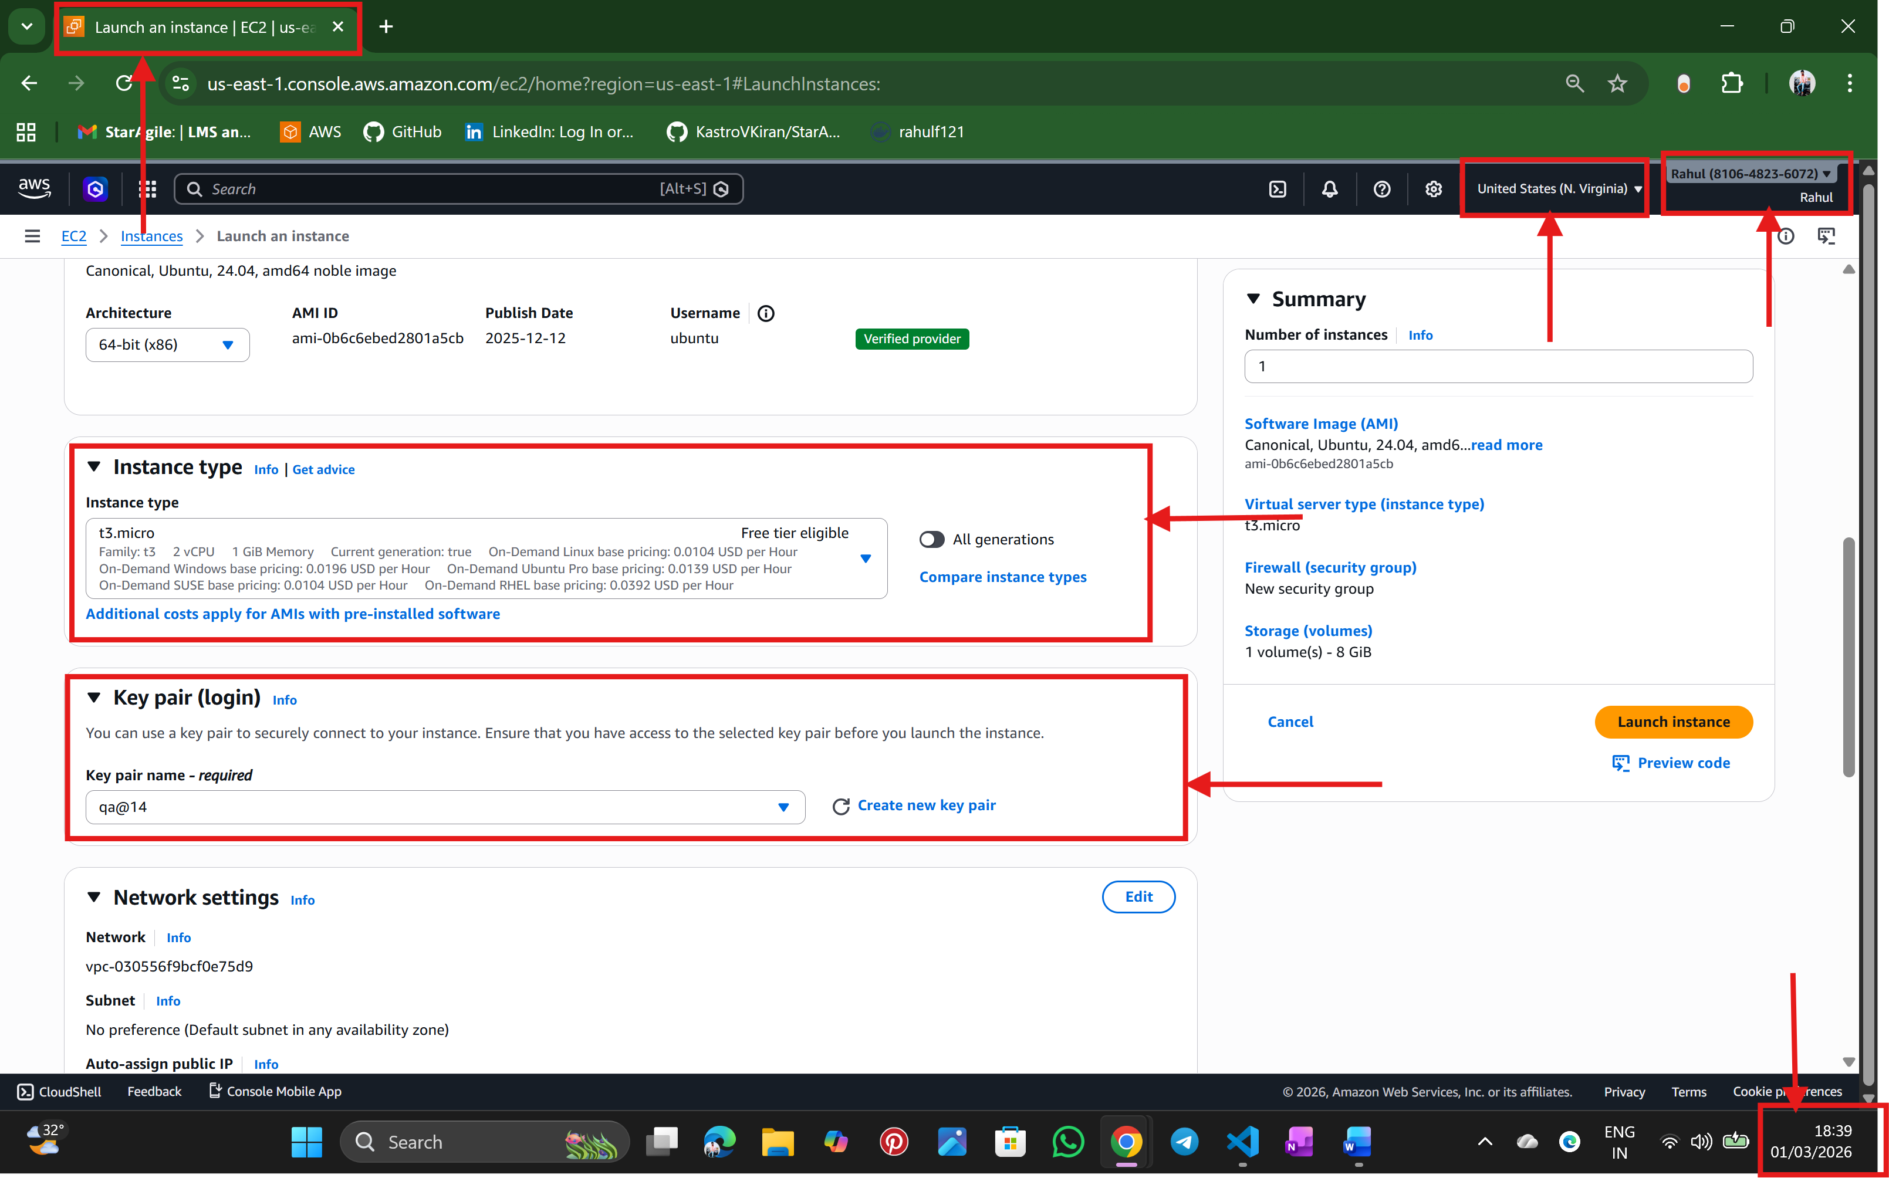
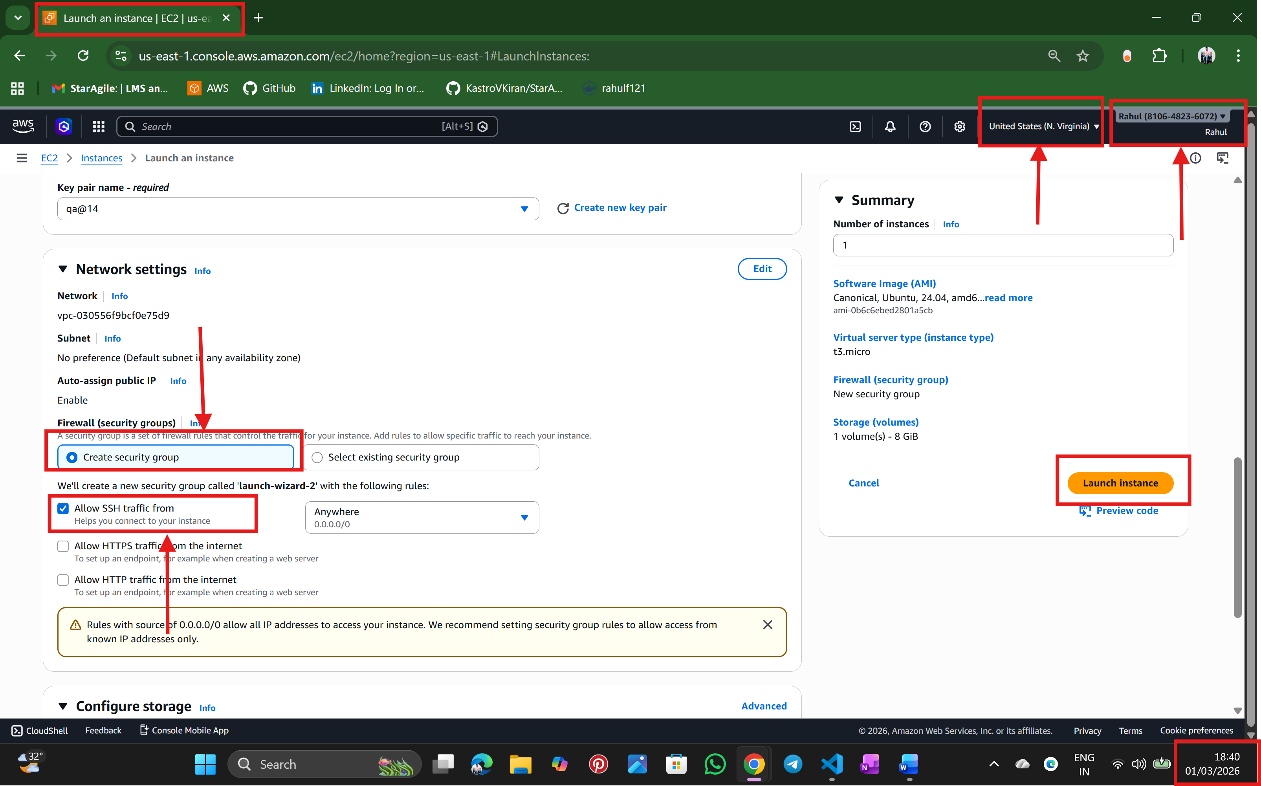
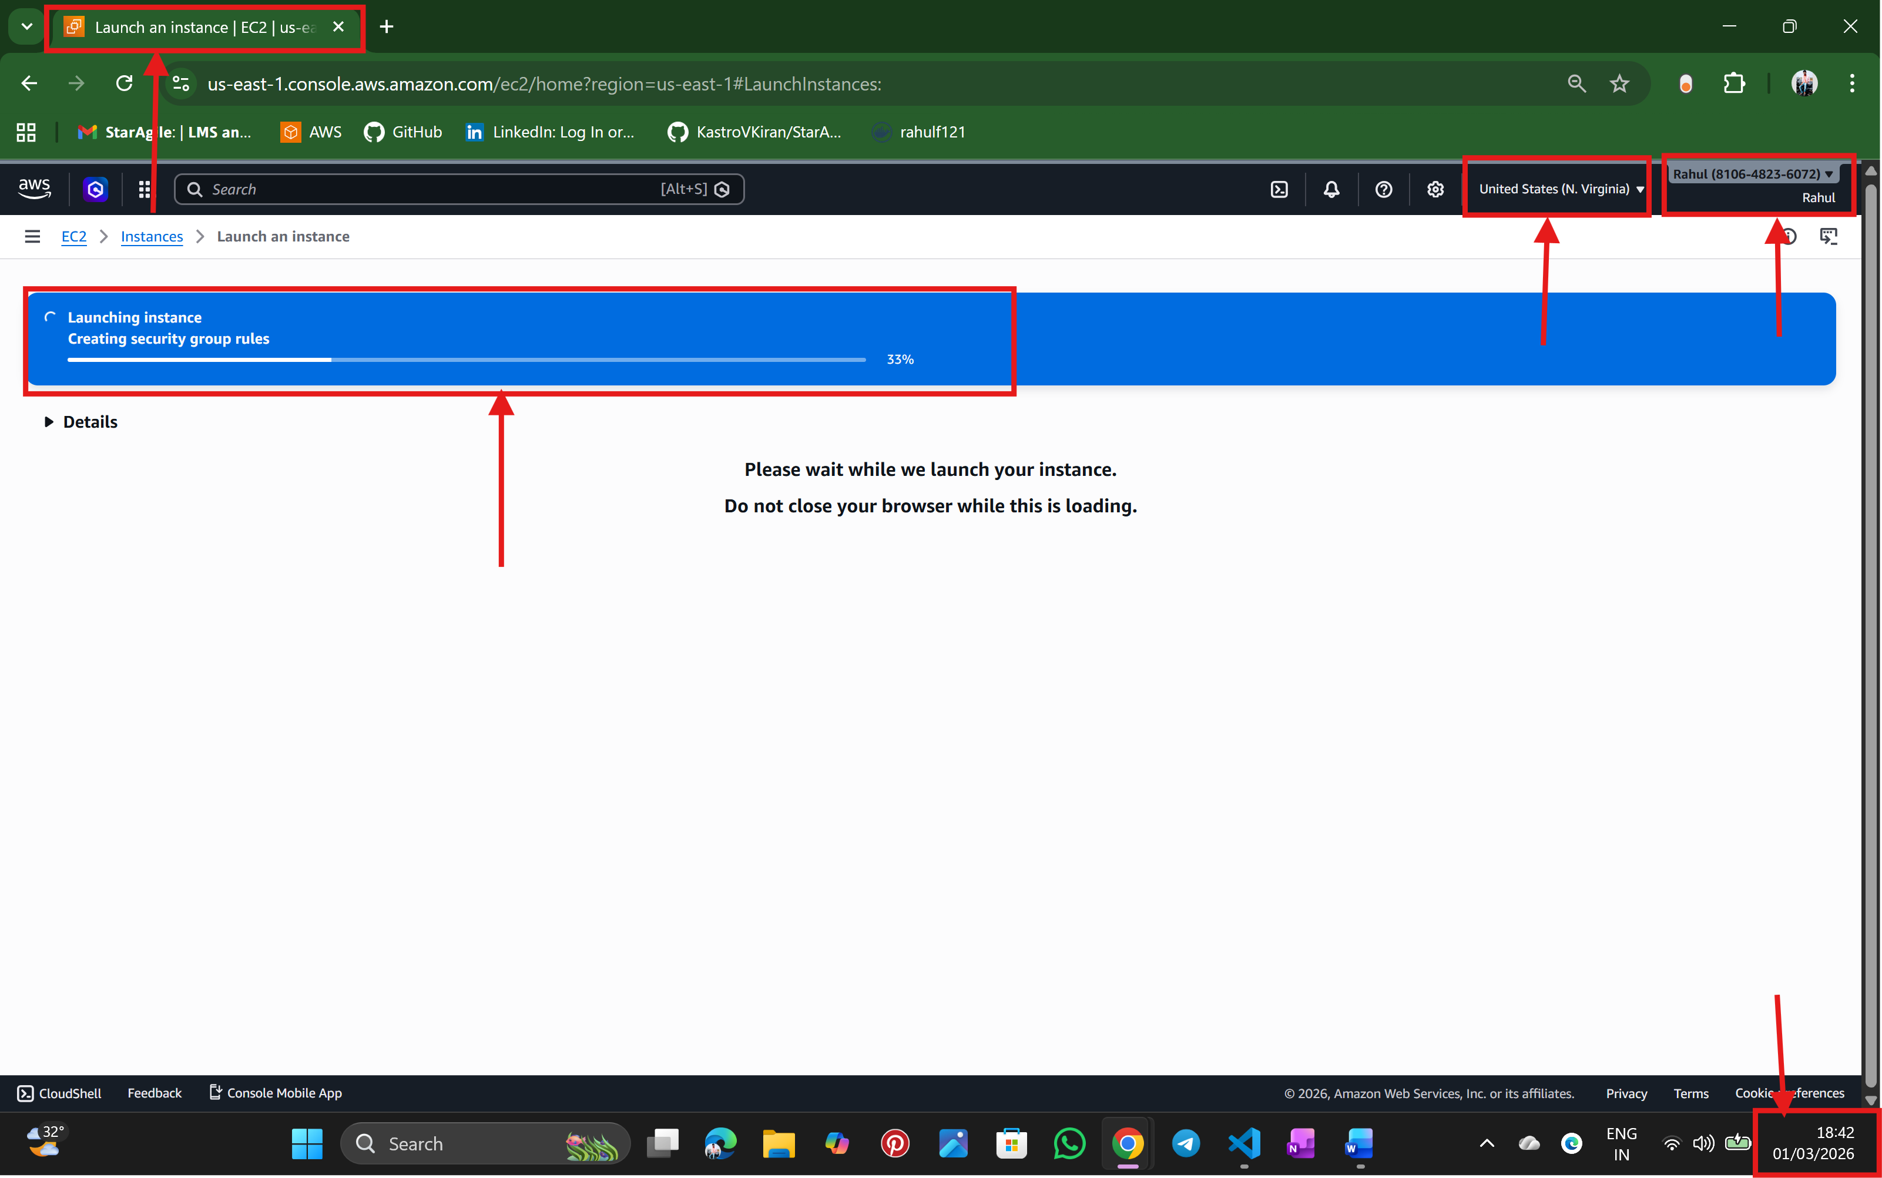
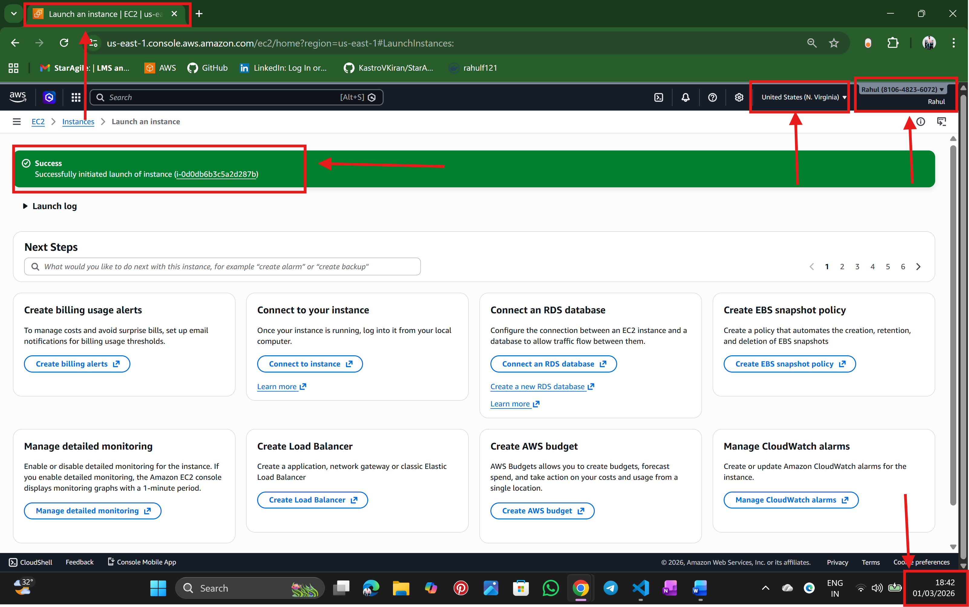

Step: 3 connect the instance using SSH Client with Mobaxterm
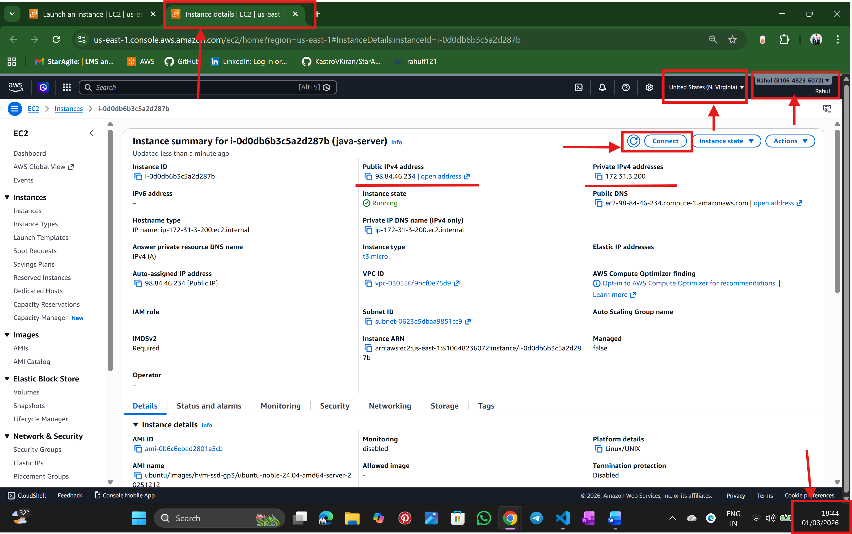

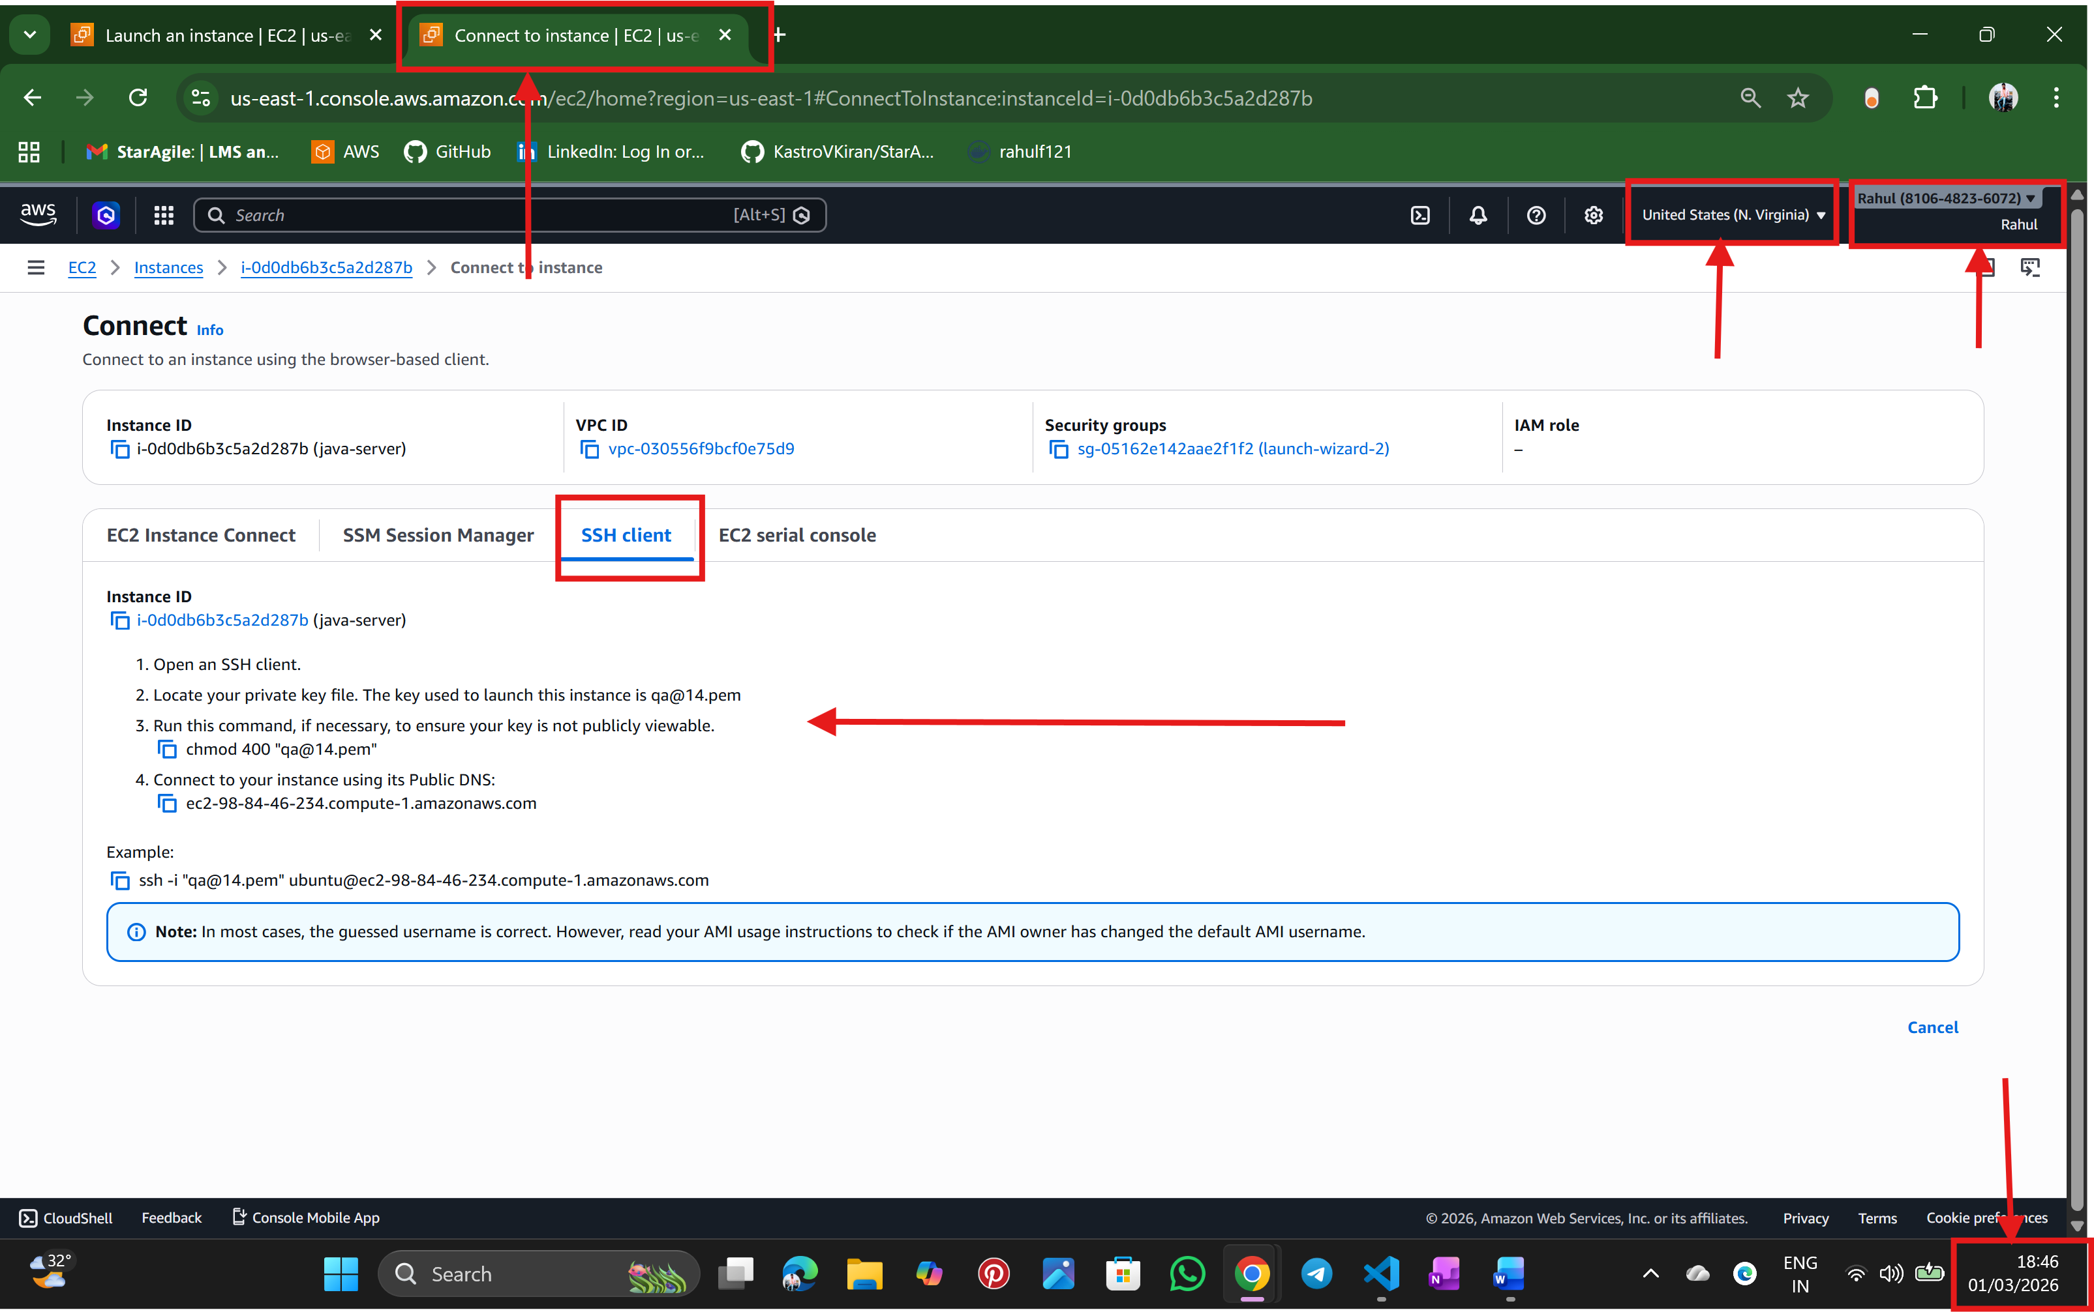
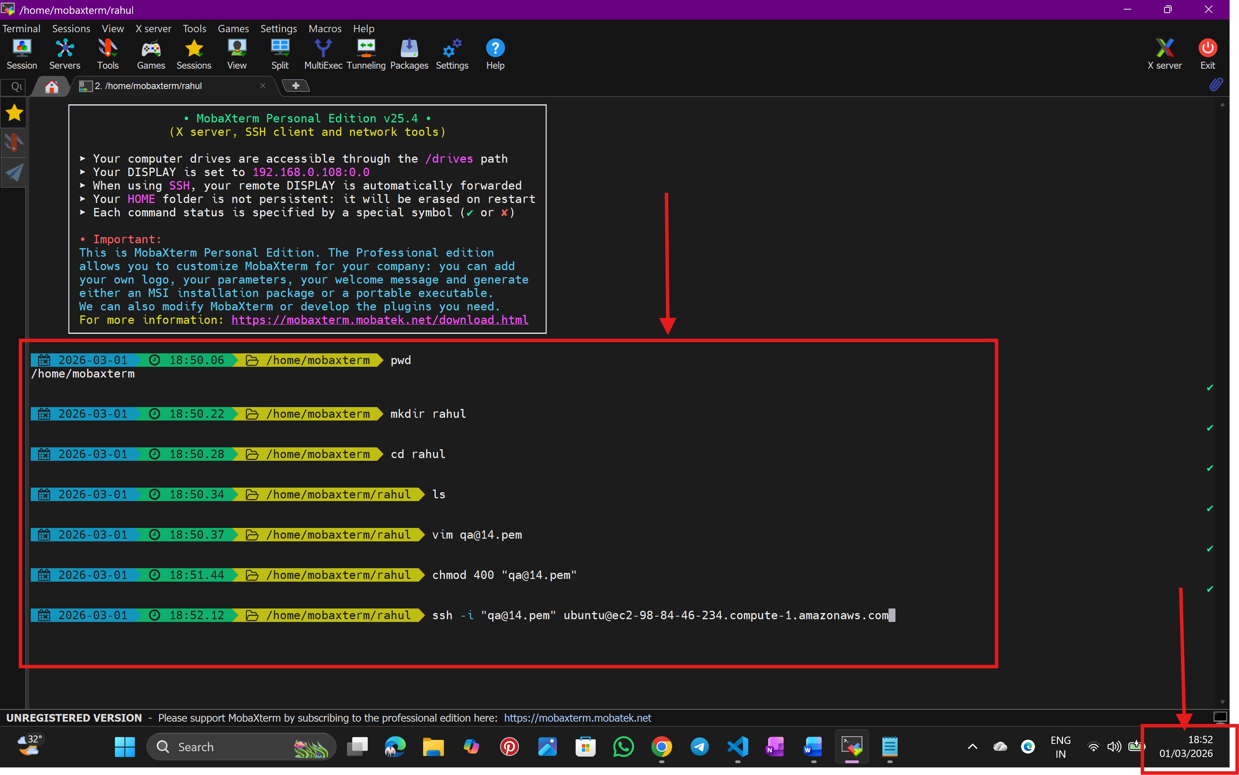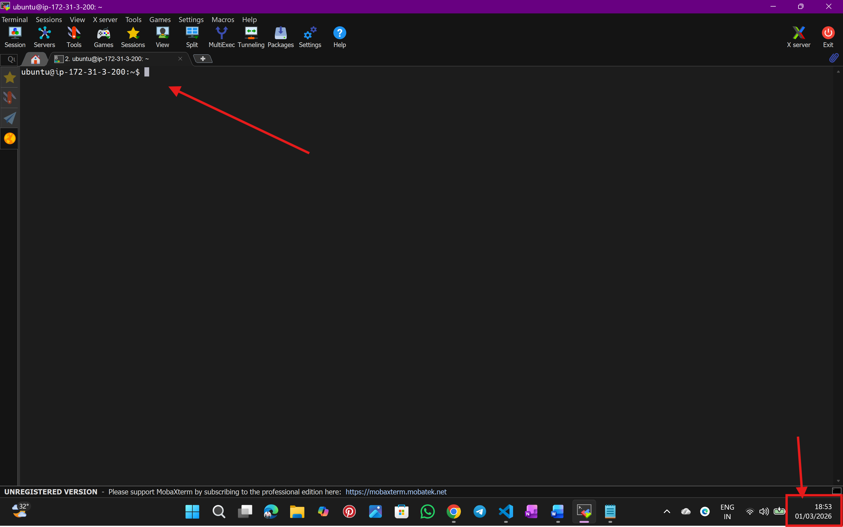

Step:4 Below window is the Mobaxterm Terminal
update system packages
- sudo apt upgrade -y
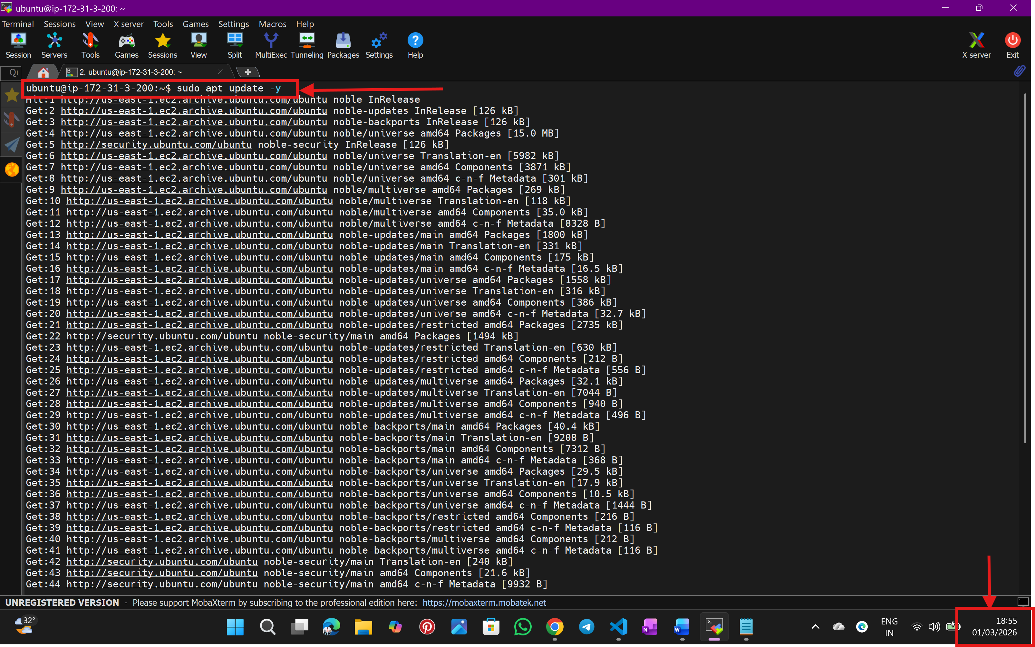
Step:5
Install JDK
- sudo apt install openjdk-17-jdk -y
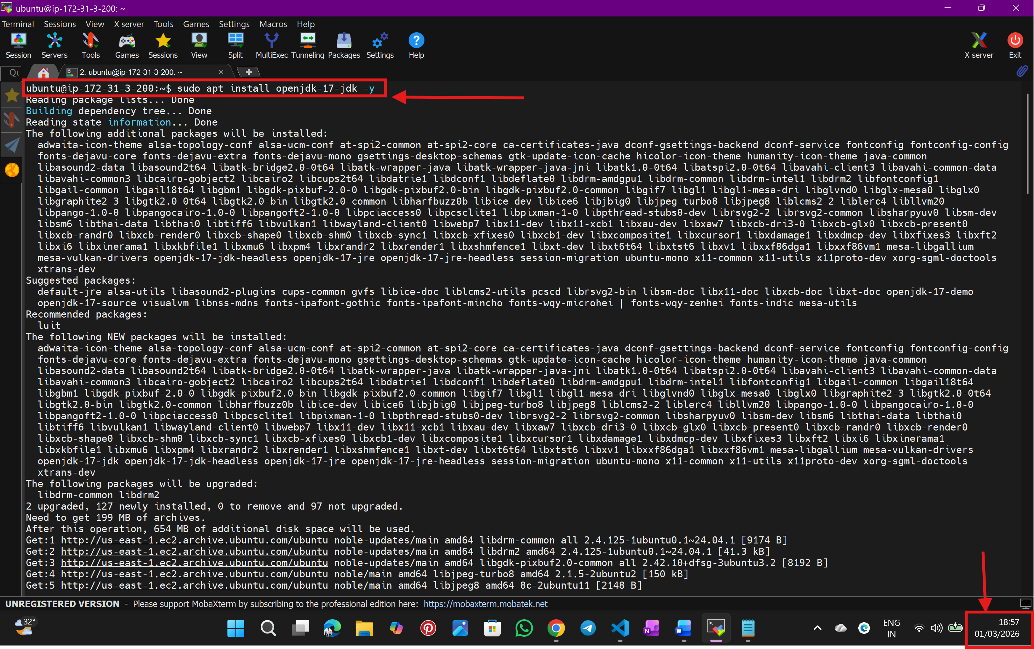
Step:6
To Verify Installation
- java –version
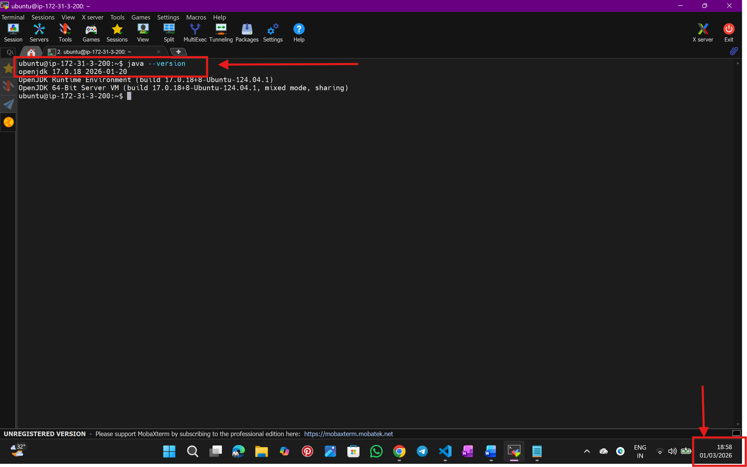

Step:7
To Find the Correct Java Installation Path
- readlink -f $(which java)
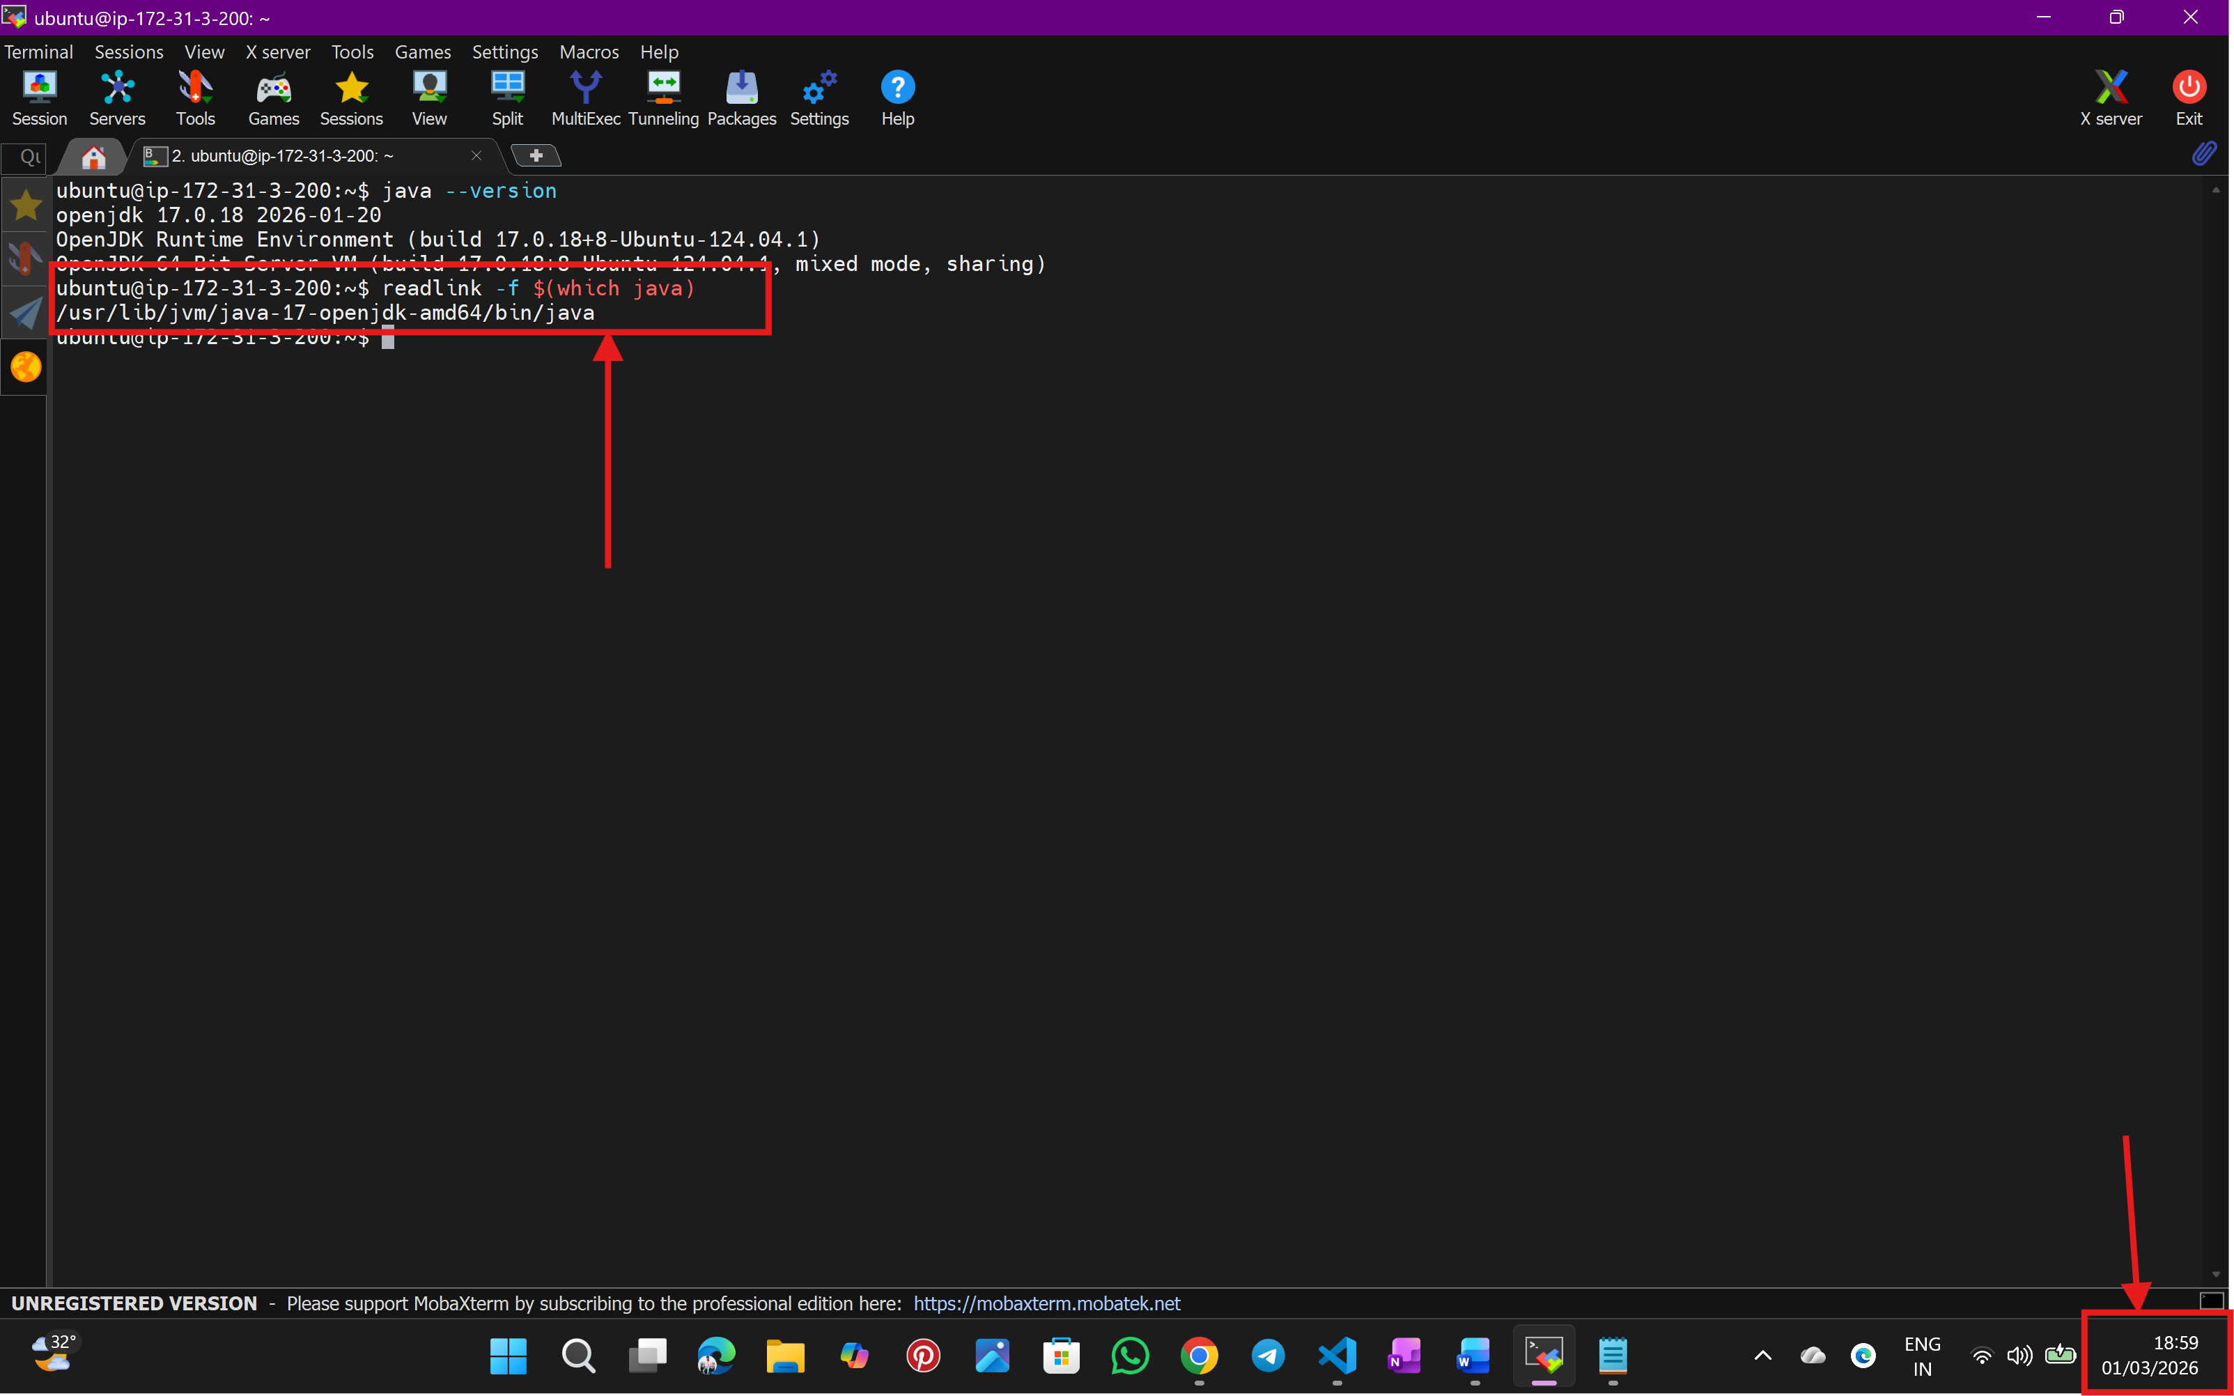

- output: /usr/lib/jvm/java-17-openjdk-amd64/bin/java
- /usr/lib/jvm/java-17-openjdk-amd64 remove /bin/java

Step:8
Creating a variable: JAVA_HOME
- export JAVA_HOME=/usr/lib/jvm/java-17-openjdk-amd64
- export PATH=$JAVA_HOME/bin: $PATH
To Verify: echo $JAVA_HOME
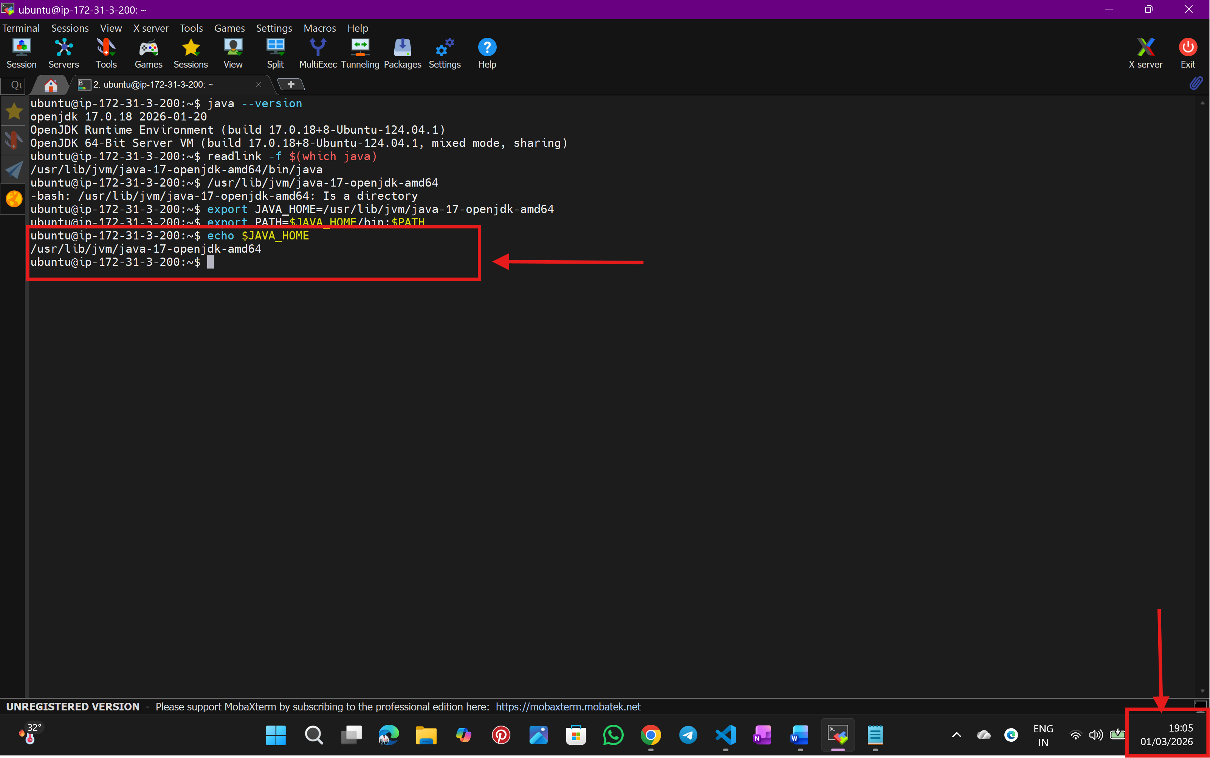
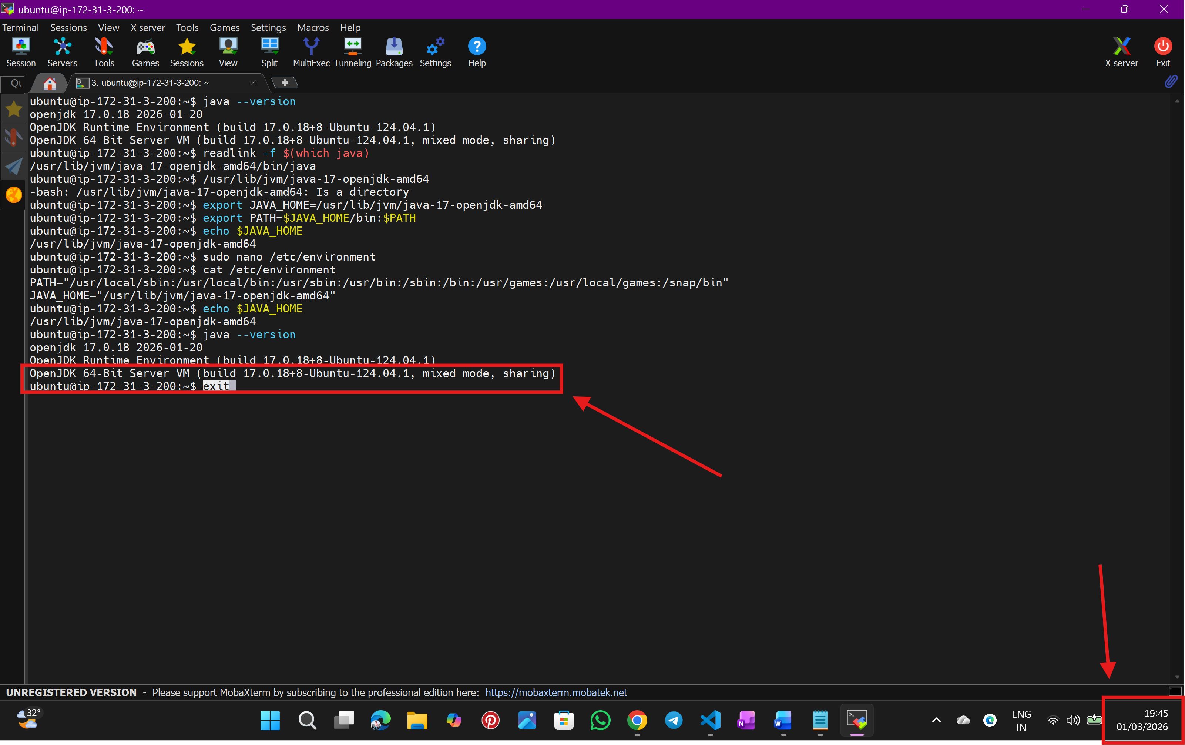
Step:9
Set JAVA_HOME Permanently
- sudo nano /etc/environment
- add this line: JAVA_HOME="/usr/lib/jvm/java-17-openjdk-amd64"
- Save and exit
Reload
- source /etc/environment


Step:10
Verify Permanent Setup
- Logout: exit
- Login again via SSH:
echo $JAVA_HOME
java -version

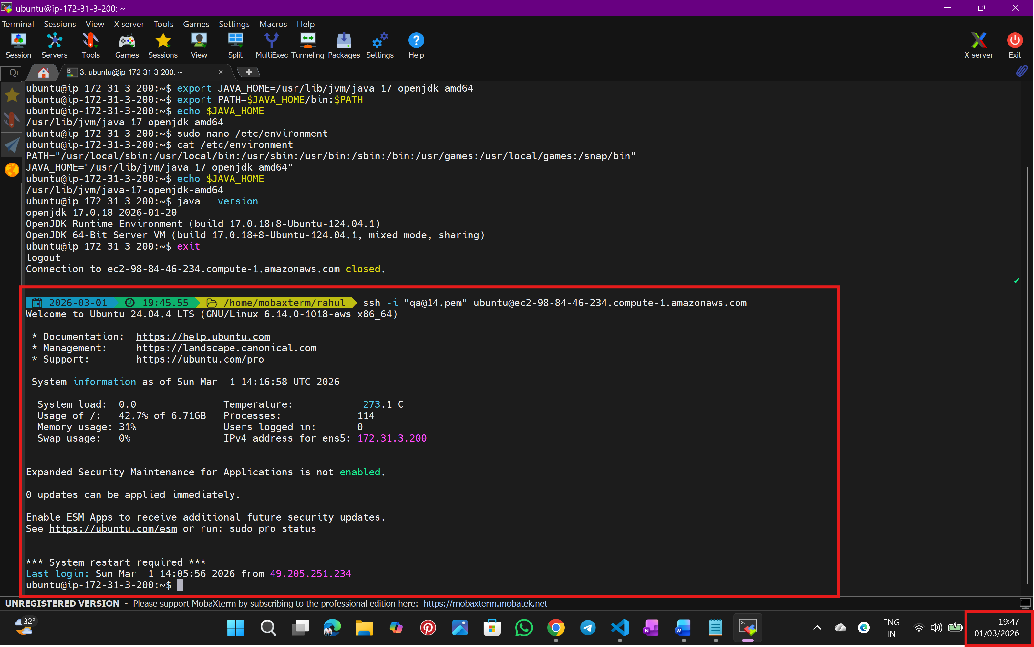
Step:11
output:
/usr/lib/jvm/java-17-openjdk-amd64
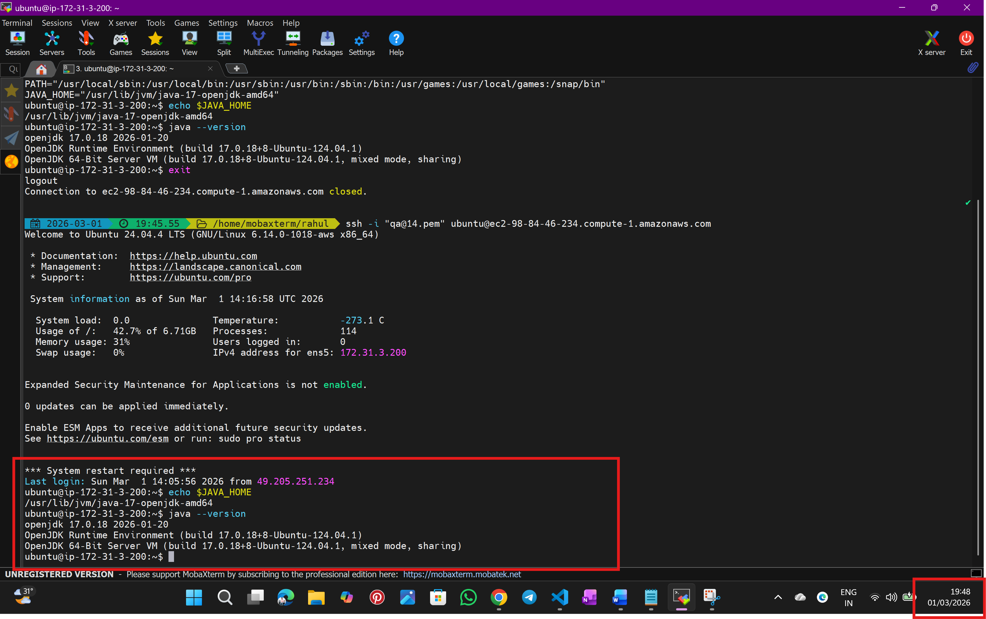
----------------------------------------------END---------------------------------------------------

